CHAPTER 7: Global systems
Worksheet 7.4

Global warming
Student: Class:
The two graphs below show information about the atmosphere during the twentieth century.

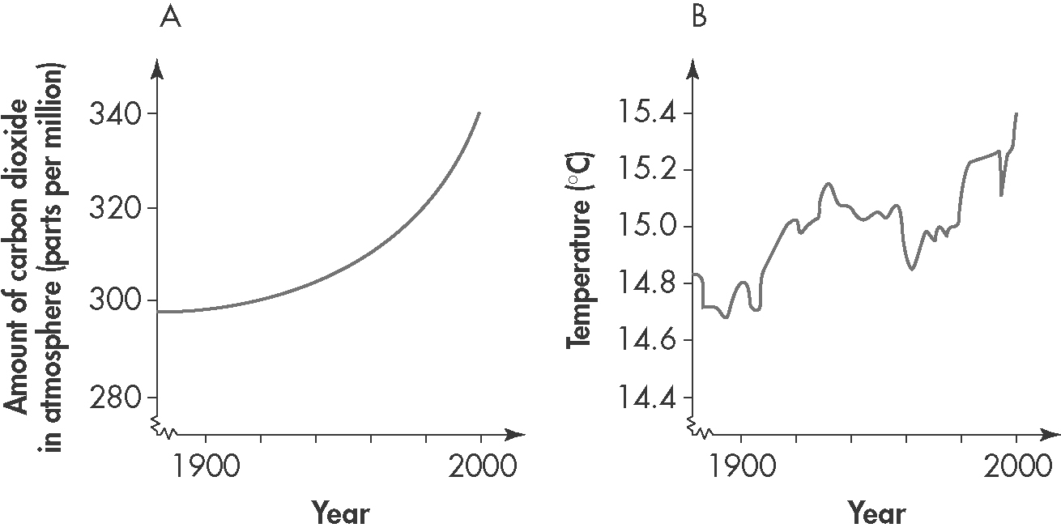
1. The increase in carbon dioxide levels in the atmosphere over the 100 years of the twentieth century as a percentage is approximately:
A. 14%
B. 40%
C. 297%
D. 337%
2. The percentage increase in atmospheric temperatures over the 100 years of the twentieth century is approximately:
A. 4.7%
B. 14.8%
C. 15.4%
D. 2.35%
3. (a) Identify the major source of carbon dioxide in the atmosphere.

(b) Explain the connection between carbon dioxide and global warming.

(c) Outline possible strategies for reducing the amount of carbon dioxide that enters the atmosphere.

CHAPTER 7: Global systems
Worksheet 7.4

Page 2

Greenhouse effect
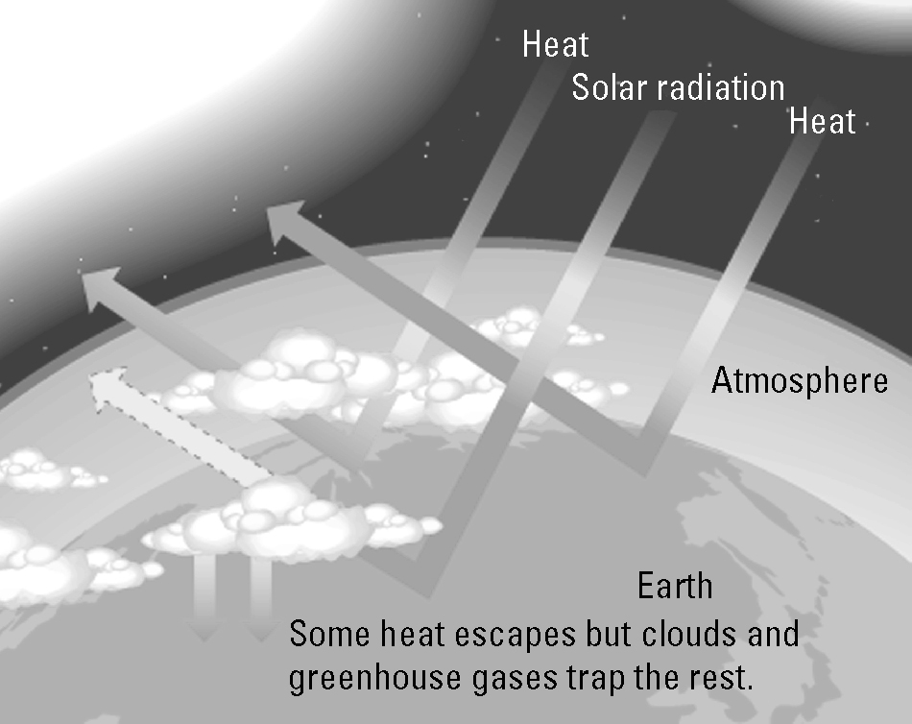 | 4. (a) Use the graphic on the right to explain how the natural greenhouse effect keeps our planet warm.
(b) Identify the cause of the enhanced greenhouse effect.

(c) Explain why the enhanced greenhouse effect is of major concern.

Carbon dioxide concentrations
5. The following table provides atmospheric carbon dioxide data over recent times.
(a) Plot a line graph of this data and draw the line of best fit.
Year | CO₂ (ppm) | 
1960 | 317
1965 | 321
1970 | 327
1975 | 332
1980 | 340
1985 | 347
1990 | 356
1995 | 362
2000 | 370
2005 | 381
2008 | 386
(b) Global average temperatures have risen during this period. Is this evidence sufficient to state that global warming is caused by increases in carbon dioxide levels? Explain.

